Setting Up Eclipse Development Environment
Before you get started.
- If you can, find a partner to set up together.
- You should first have your git repository set up.
- Review Types of Files
  - ZIP is a compressed packed folder, must extract first
  - EXE is a Windows installer where you double-click to install
  - DMG is Mac disk image double click to install
- Take your time reading instructions so you do not need to do it over. Going slow now can save time later.
- Download this document and put it in your github repo tech doc folder.
- See Windows or Mac set to install JDK and Eclipse instructions below. After that you will follow the same instructions for creating a java project and program in Eclipse

1. Install Java SE Dev Kit and Eclipse
Windows Setup
Step 1: Download Correct Java SE and Eclipse Installers
Step 2: Install Java SE Development Kit
Step 3: Install Eclipse
Step 3: Setup Environment Variables
Step 4: Set Eclipse
Mac Set Up
Step 1: Download Correct Java SE and Eclipse Installers
Step 2: Install Java Development Kit (JDK)
Step 3: Set Up Eclipse
2. Creating a Java Project and Program in Eclipse (Windows or Mac)
Step 1: In Eclipse Create a Java Project
Step 2: Create, Compile and Run a Java Class File
Step 3: Github Desktop: Version and Backup
Troubleshooting Eclipse
Exit code 13 error

1. Install Java SE Dev Kit and Eclipse
Note that some of the dialogs may not look exactly the same. Each semester the version changes. So you may see different version numbers in the screenshots.

In order to write and run a Java program you need SE JDK (Java Development Kit) For example, as of December 8th the latest Java SE Development Kit is version 25.

Windows Setup

Step 1: Download Correct Java SE and Eclipse Installers
It may take a while to download.
- First you need to find out your architecture for your operating system. See Determine Operating System and Architecture

What Windows Shows | Architecture Name | Java Download
x64-based processor | x86_64 | Windows x64
ARM-based processor | AArch64 | Windows ARM64
- Download Correct Java SE Development Kit for your OS and Architecture. It is important you download the correct file. They can be downloaded into your downloads folder and deleted after installation.
- Go to Java Downloads | Oracle Select your Operating System Tab and select the correct
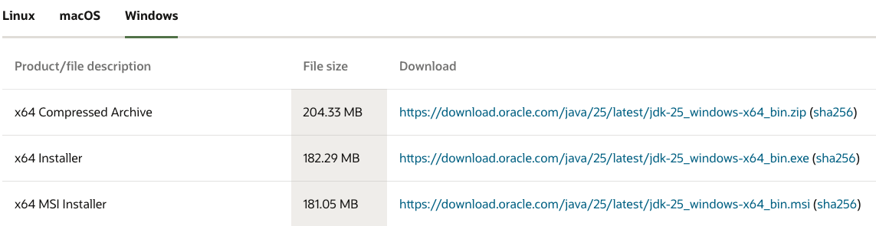

Most of you will be installing x64 Installer
Only students whose system explicitly says: “ARM-based processor” should choose Windows ARM64 / AArch64 instead.

- Download the correct Eclipse Version by clicking the link for the correct OS and architecture. Again most of you will be downloading x86_64
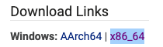

Step 2: Install Java SE Development Kit

- Go to the JDK file downloaded in step 1.
- Once the download completes, start the installation by double clicking on the downloaded .exe in the browser or in the directory it is saved in.
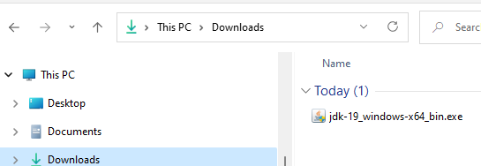

- You will be asked if you want to allow this app to make changes to your device - click Yes. Note: The installation can take a bit to get started – it can be slow - so be patient.
- You will see the Welcome dialog – click Next to start download
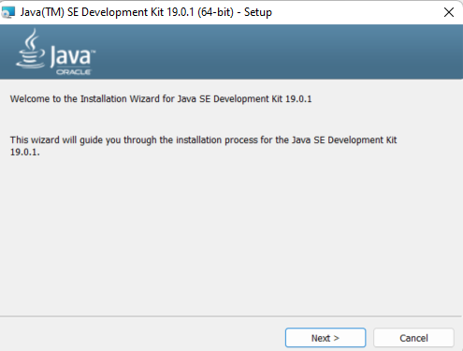
- The next dialog offers some options – click Next. Notice that the JDK (Java Development Kit) will be installed in the Program Files/ Java directory. This is where it should be installed so don’t change the location.
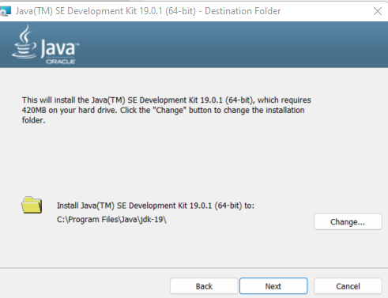
- When installing the status window may or may not display. – be patient, it takes time to get started. When the window shows successfully installed click close.
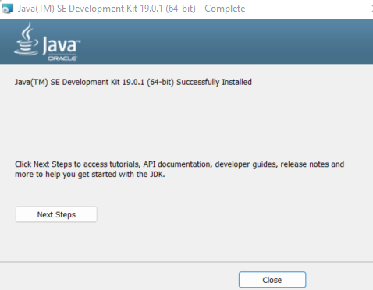

Step 3: Install Eclipse
- Go to the Eclipse-java- zip file downloaded in step 1.
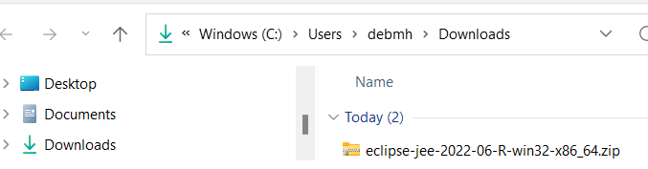

- Create a folder called JavaDev on your C: Drive
- Eclipse is a bit different since you don’t actually “install” it. Instead, because it is a zip file you will extract it to a directory of your choice.
  - In the dialog, Click Browse and go to your windows (C:) drive
  - Select show extracted files when complete. The unzip will start after you click extract– this could take a while depending on your system.
On my personal systems, my preference is to create a "JavaDev" directory on my C drive and unzip Eclipse there - C:\JavaDev. DO NOT PUT IT IN YOU GIT REPOSITORY or ONE Drive
When you start to do more development, having a development directory on your machine helps keep all development tools in one place.
NOTE: Placing the eclipse file too deep into the file structure causes an error.

You can click new folder to create a JavaDev folder
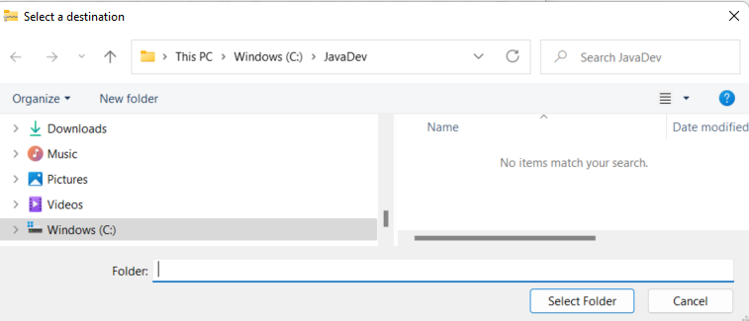
When the unzip completes, go to the location you selected and view all the files
On my system that location is C:\JavaDev\eclipse
Note: if you ever need to uninstall Eclipse, just delete the eclipse directory.
Note, when reinstalling or updating eclipse your workspace will be backed up in your git folder!
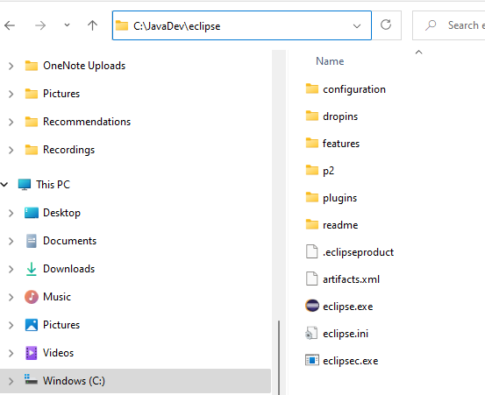

Step 3: Setup Environment Variables
Remember to go slow and pay attention to details. Note that the versions shown in the screenshots below may not match the latest version you are installing.
- Find where the JDK is on your hard drive. It should be in the Program Files directory in the Java directory: C:\Program Files\Java\jdk-25

- Go one more level down to the bin directory
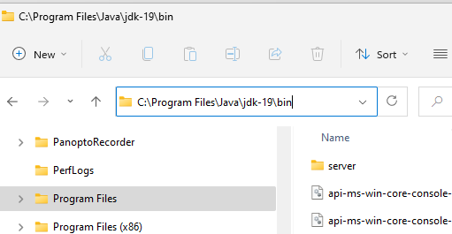

- In the File Explorer window, click in the little window where the path is shown which will highlight the path.
  - Make sure the path includes the bin directory: C:\Program Files\Java\jdk-25\bin
  - Copy the path to the bin directory (since it's highlighted use CTRL-C to save it in the buffeR or right click to copy.)
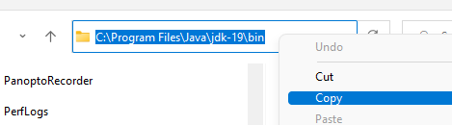
- Go to settings. You can Search for settings
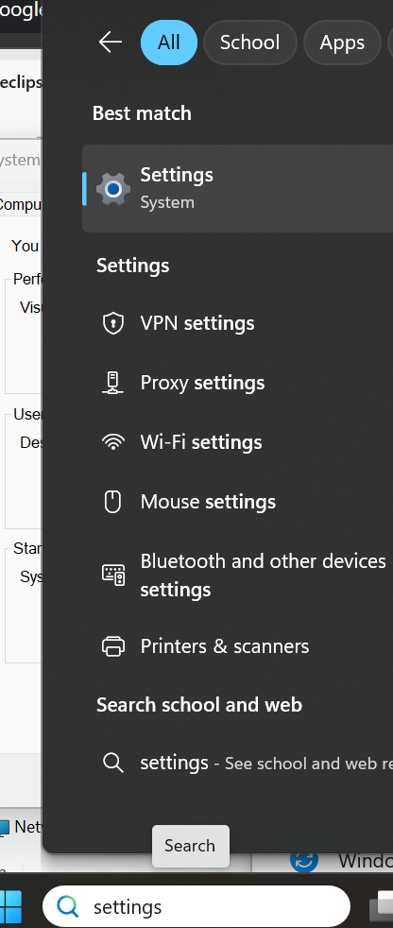
- A new window will appear showing your system information. On the right, scroll down to Related Settings and click “Advanced system settings”. Might be different based on the OS version so see below for windows 10 and windows 11.
  - windows 10
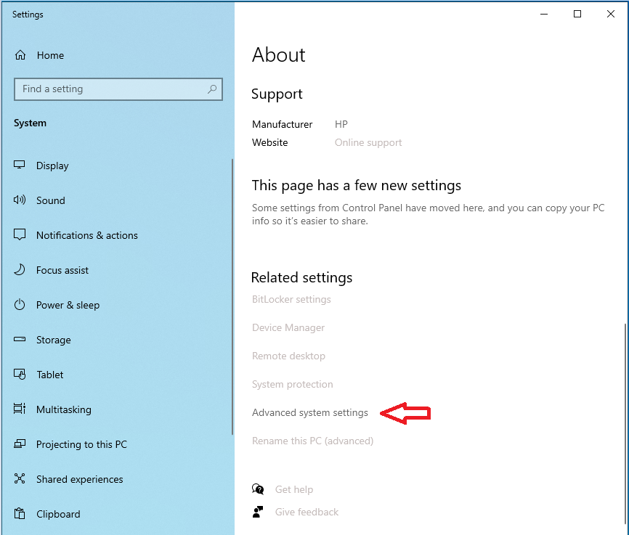

Windows 10

  - Note if you have Windows 11, I searched for environment and selected Edit the system environment variables.
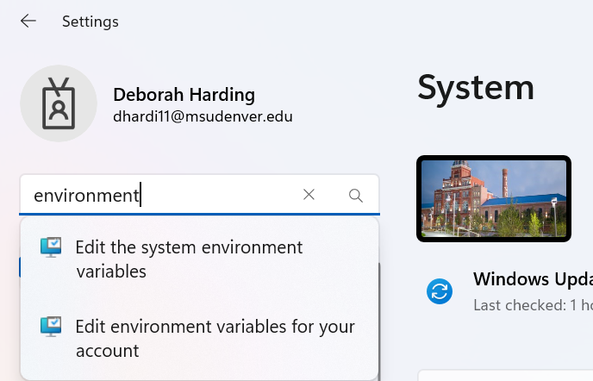
- In the System Properties window, click the “Environment Variables…” button
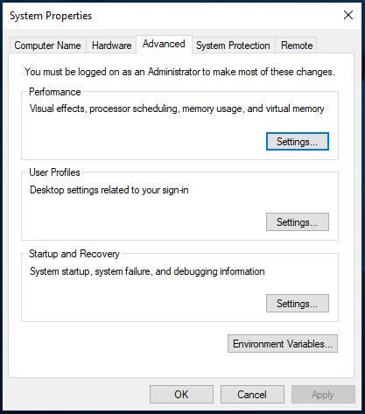

- The Environment Variables window will display. In the lower window - "System Variables" - find "Path" and single click on it to highlight
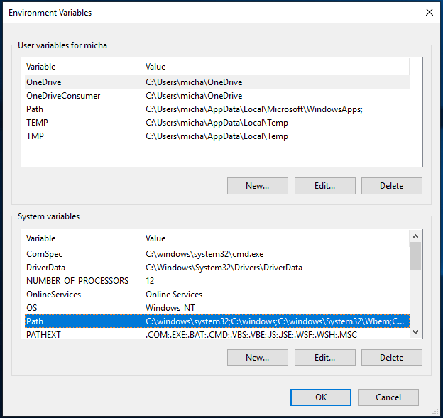
- Once "Path" is highlighted, click Edit and this window will appear.
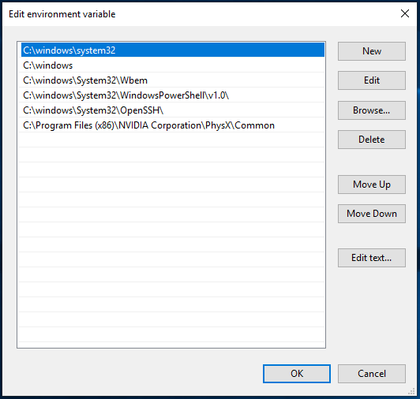
- Click New. Paste the path for the JDK bin directory into the little window adding it to your path.
  - Click on the little window
  - Use CTRL-V to paste the path saved in the buffer into the little window
  - Close all those windows by clicking OK. You can close this window.
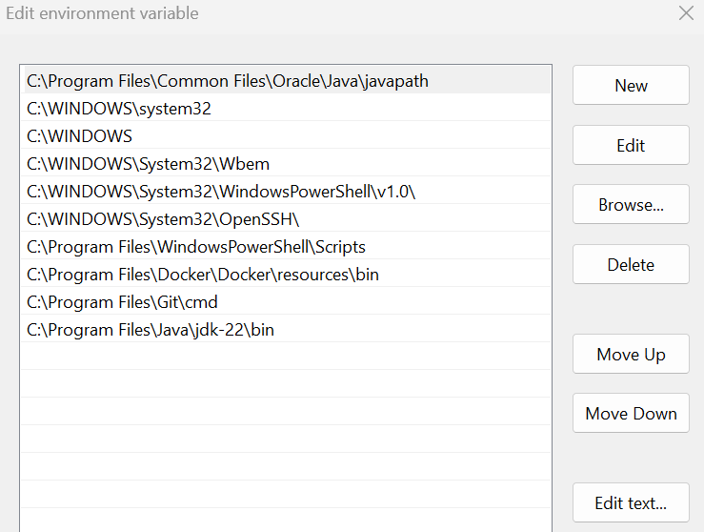Yours will be JavaSE25

Step 4: Set Eclipse
- Go to the directory where you extracted Eclipse (on my system that would be c:\JavaDev\eclipse).
- Double click the eclipse.exe file
  - If you don’t see the .exe file extension – double click the file with the round purple icon
  - To see file extensions in file explorer, click “View” then check “File name extensions”
  - You can right click eclipse and pin to taskbar to make it easier to launch
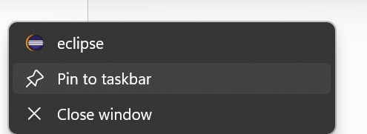
- Eclipse will ask where you want your workspace. A workspace is where the .java and .class files for your class work and assignments will be stored. You will put this in the EclipseWorkSpaceFolder you created in your git repo (Part 3: Git Repos Organize in Folders) so you can version the files using git and back up on the GitHub server. Click use this as the default.
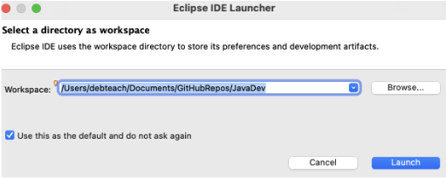

- Click launch Note: if you’re updating the version of Eclipse on your machine you will see the following dialog
  - Note: Before you update Eclipse to a newer version make a backup copy of your current workspace in case you run into issues.
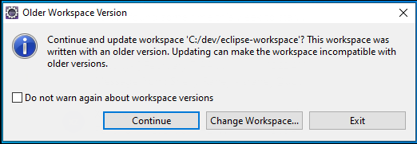
- The Welcome screen for Eclipse will appear. Click the Hide icon on the right side.
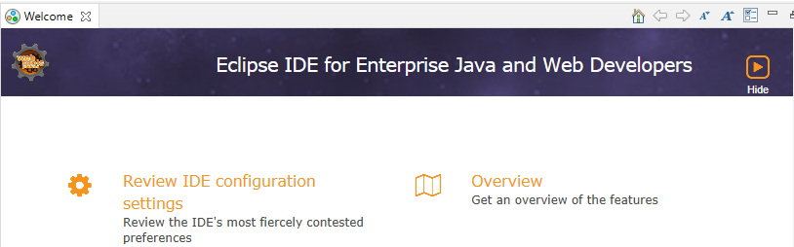

- Add JDK In Eclipse, top menu → Window > Preferences
- Expand Java → select Installed JREs. If you see only the jre selected as shown below and not the jdk as shown here 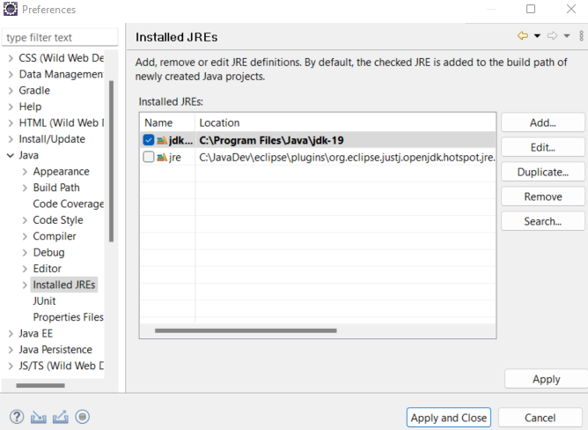 you will need to update your JRE
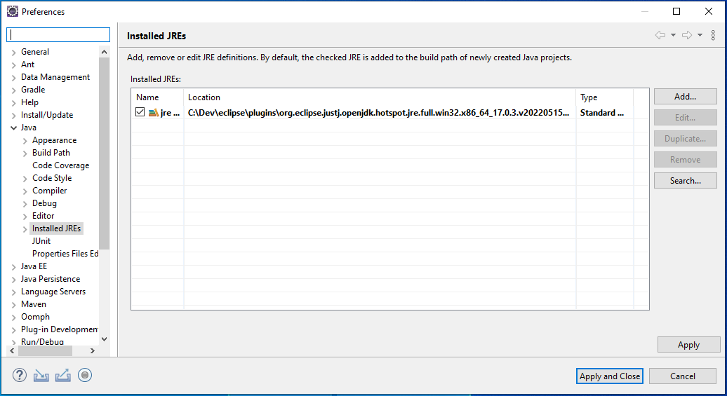

- Click Add. In Add JRE window, select Standard VM then next
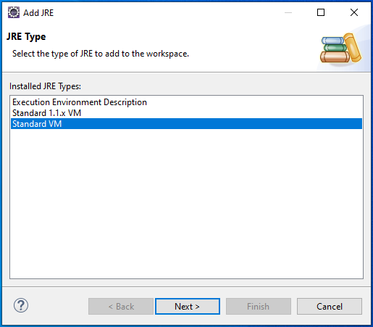
- In the updated Add JRE screen, to the right of JRE Home, click Directory...
- Browse to C:\Program Files\Java\jdk-25
- Highlight jdk-25 and click Select jdk-25 Folder
- The Add JRE dialog will now be filled in, click Finish.
- You will now see in Installed JREs dialog a new entry with jdk-25
- Select the box to the left of the jdk-25 as shown below.

- Click Apply and Close button
- You are now set up to create, compile and run Java programs! Go to Creating a Java Program in Eclipse (Windows and Mac)

Mac Set Up

Step 1: Download Correct Java SE and Eclipse Installers
It may take a while to download.

It is important you download the correct files.
- First you need to find out your architecture for your operating system. See Determine Operating System and Architecture
- Download Java SE Development Kit for your OS and Architecture.
  - Go to Java Downloads | Oracle
  - Select Mac OS tab and download the correct DMG installer - x64 DMG Installer or ARM64 DMG Installer
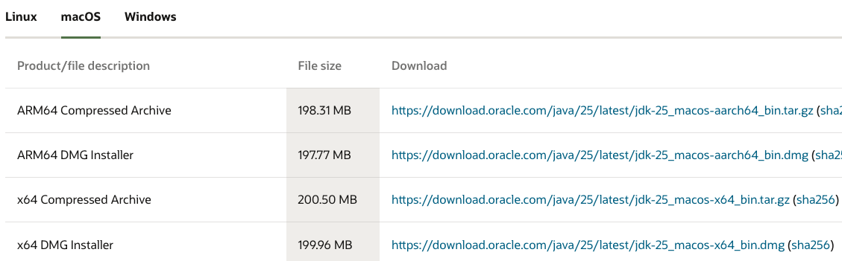

M1 / M2 / M3 is AArch64 (Apple Silicon) use
Intel is x86_64 Use

- Download the correct Eclipse Version by clicking the link for the correct OS and architecture.
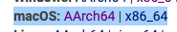

Step 2: Install Java Development Kit (JDK)
- Double click the JKD pkg
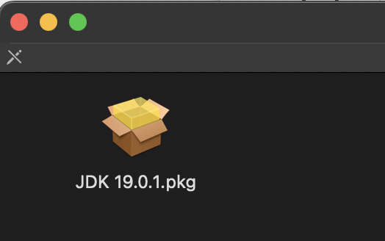
- The install window will appear. Keep Clicking continue and then install. Enter password to install the software. Then click close and move to trash.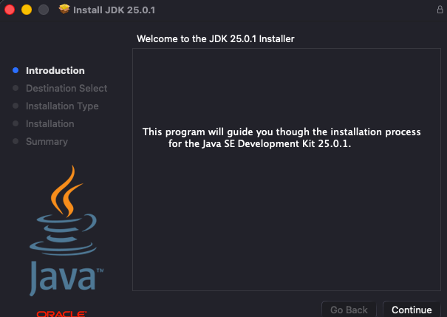

- Here is where the JDK is located. You may have more than one installed.
Yours will be JavaSE25
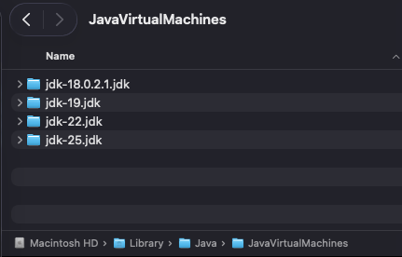

Step 3: Set Up Eclipse

- Go to the download location. Double click dmg file.

- Drag eclipse into your application folder.
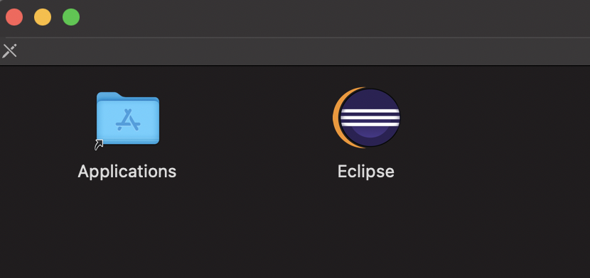
- You can go to your applications folder to open Eclipse
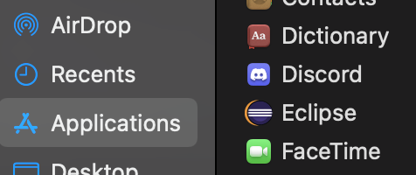
- You might be asked if you want to open- click open
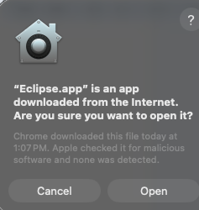

Note: if you’re updating the version of Eclipse on your machine you will see the following dialog
  - Before you update Eclipse to a newer version make a backup copy of your current workspace in case you run into issues.

- Eclipse will ask where you want your workspace. A workspace is where the .java and .class files for your class work and assignments will be stored. You will put this in the EclipseWorkSpaceFolder you created when setting up git repo

Go to your Github desktop app and click show in Finder

You will see where the EclipseWorkSpace folder is located
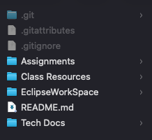
- Click browse to select the EclipseWorkSpace folder and click open
Click use this as the default.
Click Launch
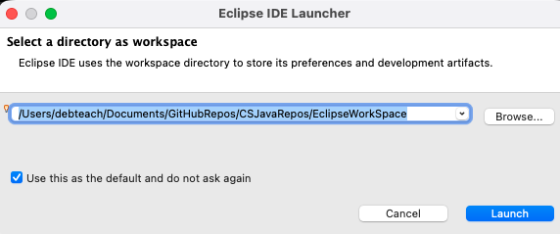
- You might need to Click ok to allow eclipse access.
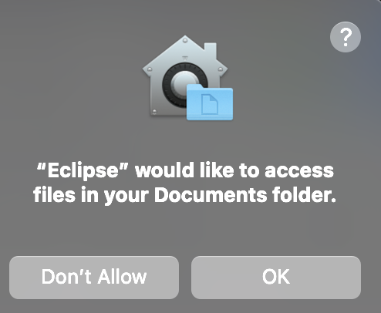
- The Welcome screen for Eclipse will appear. Click the Hide icon on the right side.
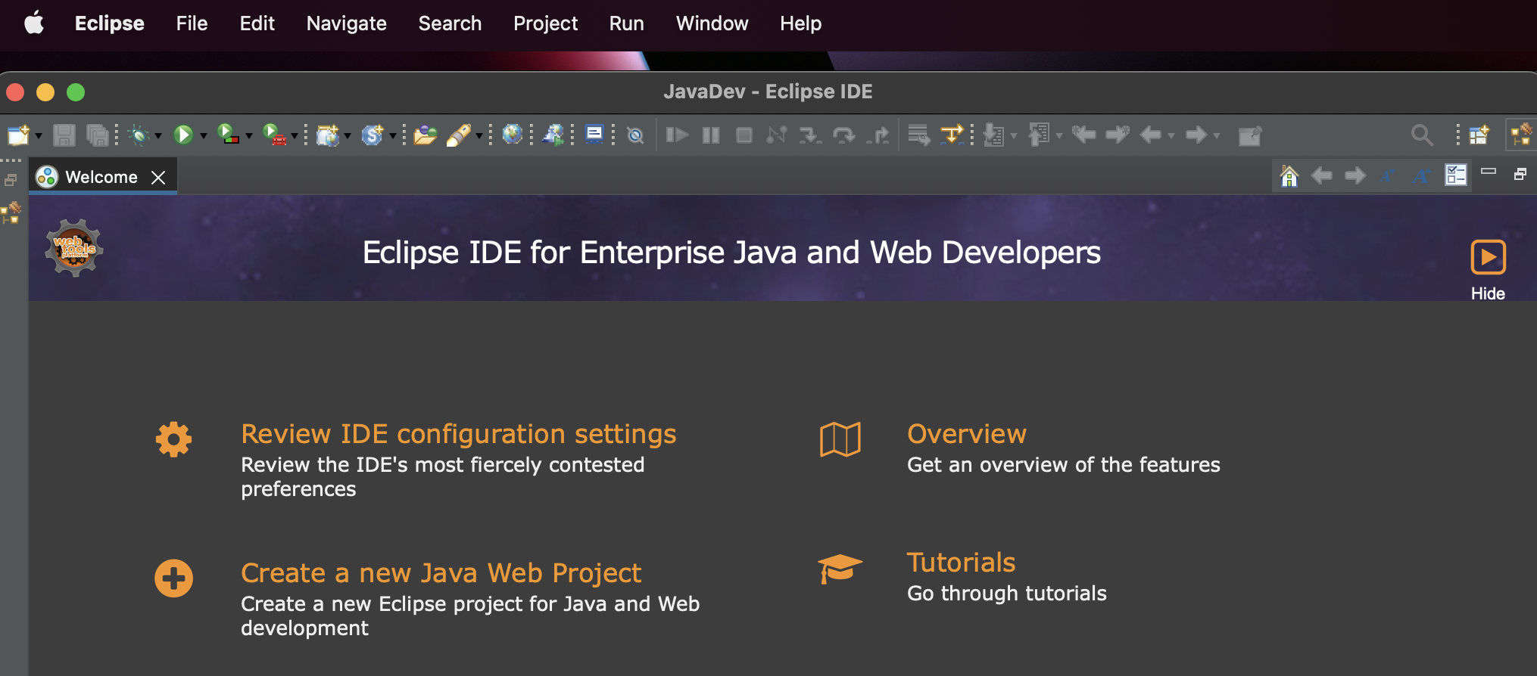
- Set up JRE. Go to Eclipse menu, select Settings (It might be called Preferences) and navigate to Java -> Installed JREs
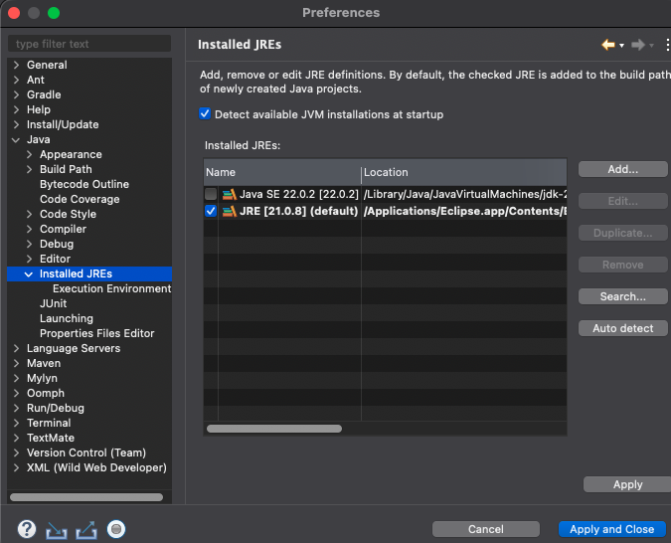

- Scroll down to Java->Installed JREs. Select Java SE25. Click apply and close. THIS STEP IS A PLACE MANY DO NOT SELECT SE - you do not want JRE. If you do not see the option for Java SE 25 follow the next steps.

  - Click add -> in next window click Standard VM and Next button.
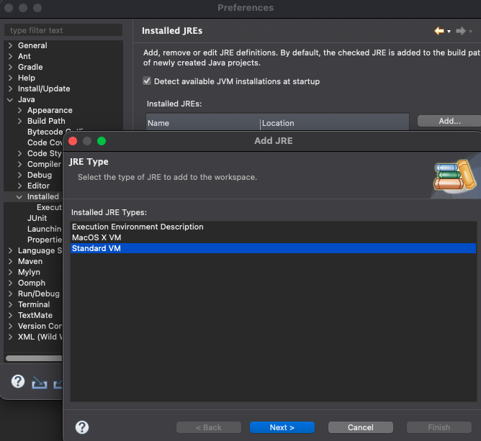
  - Click your macintosh HD
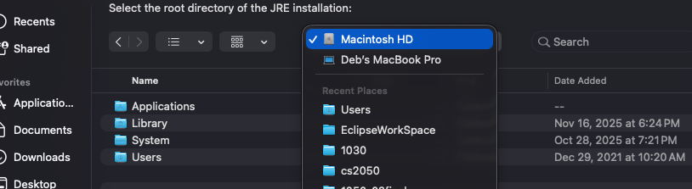

  - Next select Library folder, in that select Java folder -> JavaVirtualMachines ->jdk-25.jdk -> Contents -> Home and click open
/Library/Java/JavaVirtualMachines/jdk-25.jdk/Contents/Home/

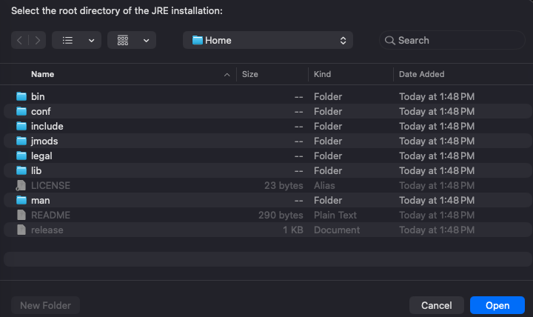

  - Click Finish
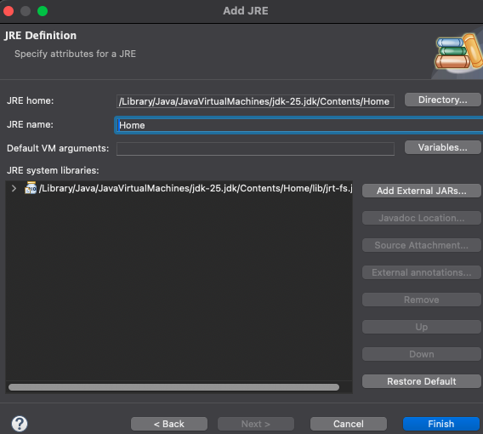
  - Unselect other selections and select Home. Click apply and close
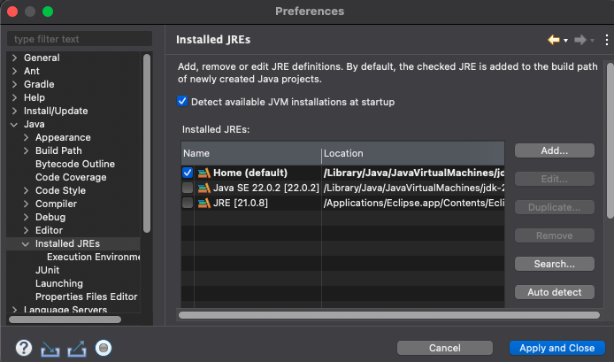
- Now that the Java SE is set go to Using Eclipse (Windows and Mac) below.

2. Using Eclipse (Windows or Mac)

Here are the steps for setting up your first java project.

Step 1: In Eclipse Create a Java Project
Take your time!

It is important to organize your work. One way is to create Java Project folders based on the module.
- On the top menu, select File->New-> Java Project to display the New project dialog
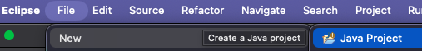

- Set the following in the Create Java Project
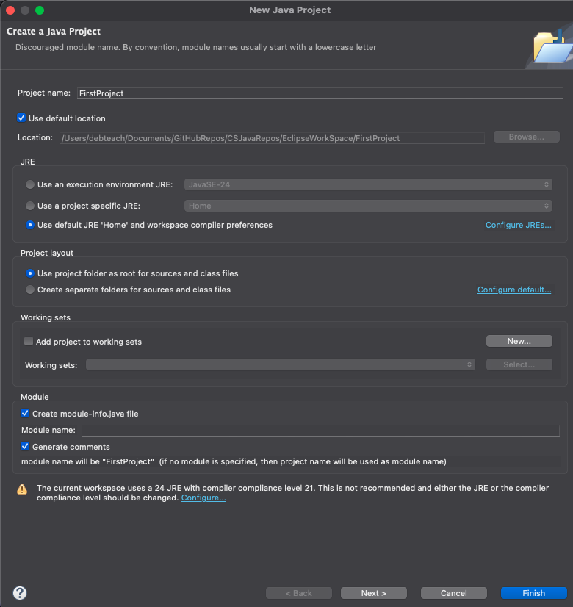

Give the project a name FirstProject
Do not use any spaces

This should already be set to the EclipseWorkSpace in your GitHubRepos/CSJavaRepos folder

Use default JRE “Home”
Select use project folder
Make sure all settings are correct.
Click Finish.
- If you see the following dialog – click “OK”
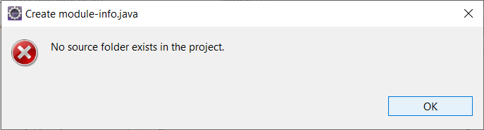
- You may also see a dialog that asks you about the Java perspective. Click Remember by decision and click “Open Perspective”
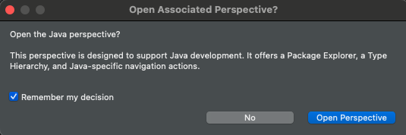
- If Welcome appears close it
- Now in Eclipse you should see the project in the package explorer. Click the > to go down to see what is in the folder. You should see JRE System Library if you set up everything correctly.
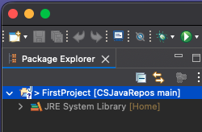
- If you go to your local repository you will see the project folder FirstProject was created in the EclipseWorkSpace
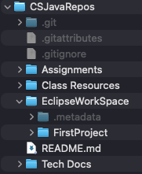

Step 2: Create, Compile and Run a Java Class File
You will create a new java class in the project folder you want. You must do the following every time you want to create a new java source file to write code.

- Make sure you have selected the project folder you want to create it in, selected.
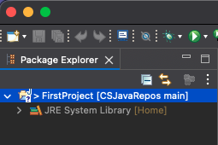
- Go to File->New->Class
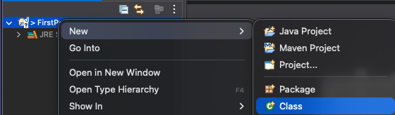
or Right click project and select New pick Class in the dialog


- Follow the step carefully (see screen below)
  - Source Folder – should be filled in with the name you gave your project
  - Package should be empty
  - Name - name for file starts with capital letter
  - Check: public static void main(String[] args)
  - Uncheck: Inherited abstract methods
  - Check Generate Comments
  - Click Finish

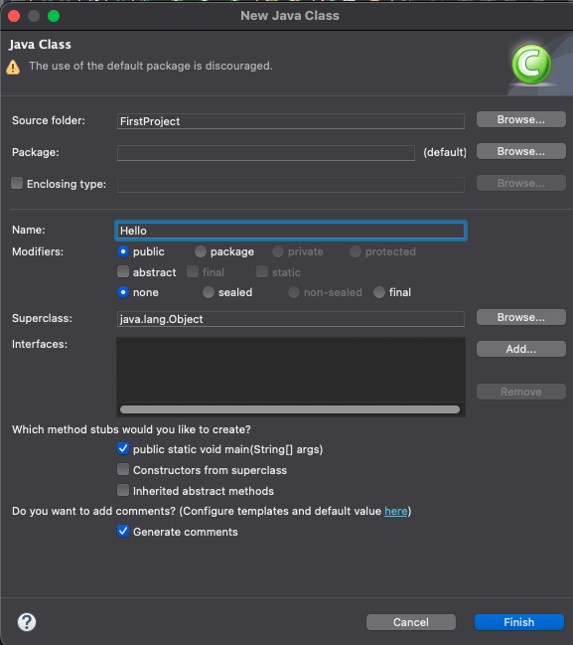
This should be your project you created it in.

Delete Package if there is one
Name start with capital letter and no spaces
Ignore
Check public static void..
And uncheck inherited abstract methods
Check Generate Comments
- In Eclipse, on the left side you will see in the Package Explorer panel and your code in the middle. You might need to double click the Hello.java file for it to open.
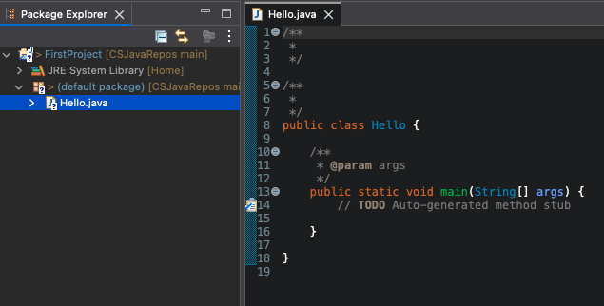

- You will repeat this step #3 (creating a java class) each time you want to create a new file.
- Go to your project located in you local repository and you should see the Hello.java file you will edit and the compile Hello.class file.
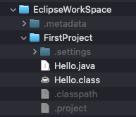
Another way to get to the directory is to right click the file then go to Show In -> System Explorer
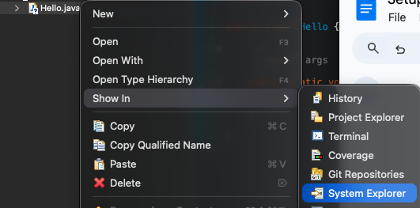
- Eclipse automatically builds the .class file In Eclipse, if you go under Projects, you will see “Build Automatically” is selected. This is how the .class file was created automatically for you.

- Add a comment and code to your first file.

public class HardingHello {
/**
* @param args
*/
public static void main(String[] args) {
// Print hello
System.out.print("Hello");

}

}

- To run your program Select "Run" from the top menu
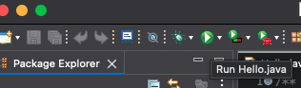

- If the Save and Launch dialog appears, select “Always save resources before launching” so you do not need to see this every time.
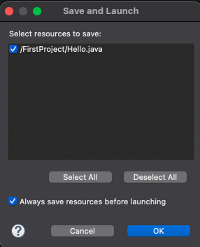

- You should see the output in the console window on bottom of the screen
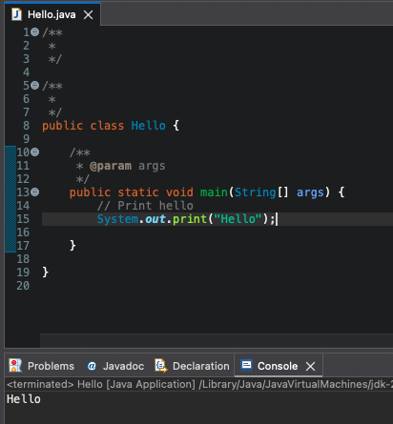

- Celebrate!

You can download this Eclipse cheat sheet to put in your github repo tech docs folder. You will be using this every time you use Eclipse. We will learn new parts about Eclipse throughout the course.

Step 3: Github Desktop: Version and Backup
- Go to your github desktop and you should see the following. This is showing your new .java file. You need to version the file locally by committing. Create a summary of about the files and then commit to main (version on your local computer)

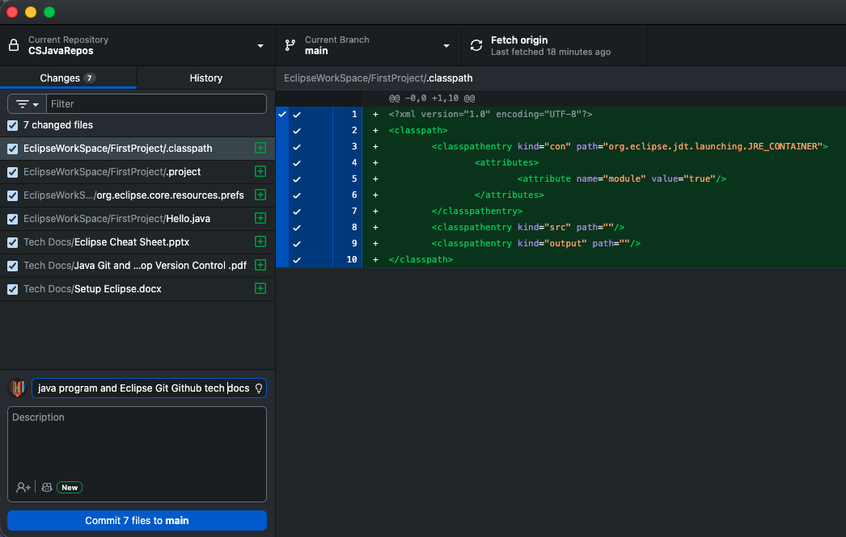
- Next you will push the update to the github server.
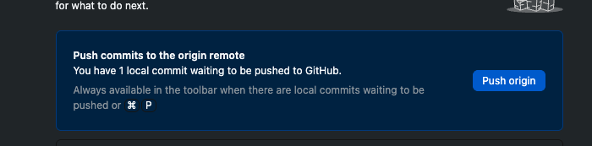
- You can view on github server to see that everything is backed up. You will see the comment on the folders and files you pushed.

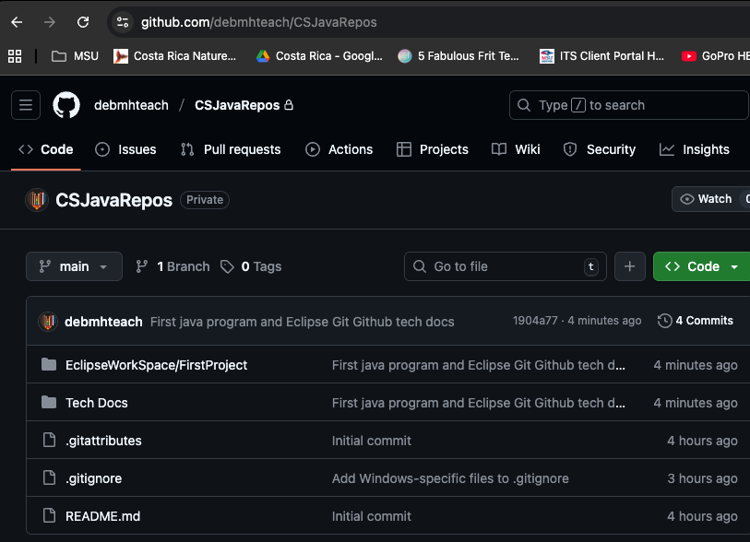

Troubleshooting Eclipse

Exit code 13 error
This error occurs when there is more than one version of the JRE on your system.

- Note that you have 2 directories on your C drive:
    - Program Files
    - Program Files (x86)
- You correctly installed the JDK into the Program Files
    - The Program Files directory is the correct location for the JDK so don’t mess with it.
- Exit code 13 occurs when there is a java directory in Program Files (X86)
    - If you have a Java directory in Program Files (x86), Eclipse will use it instead of the one you just installed in Program Files.
    - You need to UNINSTALL the java directory in Program Files (X86)
    - Uninstall is different from deleting, so DO NOT delete the directory.
- To fix this issue:
    - Uninstall the JRE in the Program Files (X86) directory
    - The new JDK that you just installed already contains the JRE.
    - Open the Control Panel
    - Select under Programs “Uninstall a program”
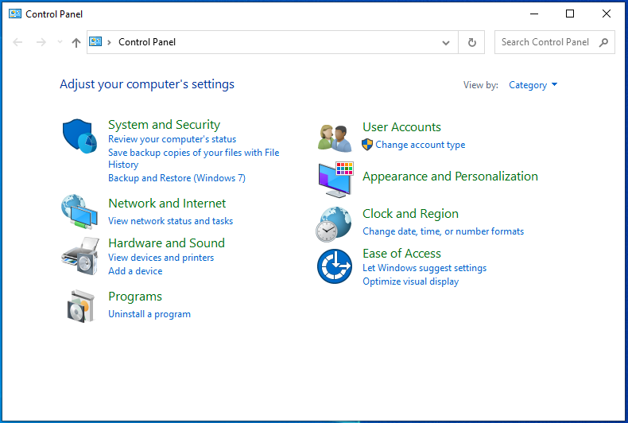
- You next screen will appear with a list of all the programs installed on your system
    - Locate the JRE
    - I don’t have the JRE on my system so the screen grab only shows the JDK’s so I can’t show what this looks like.
    - Once you locate the JRE, select it, then select uninstall
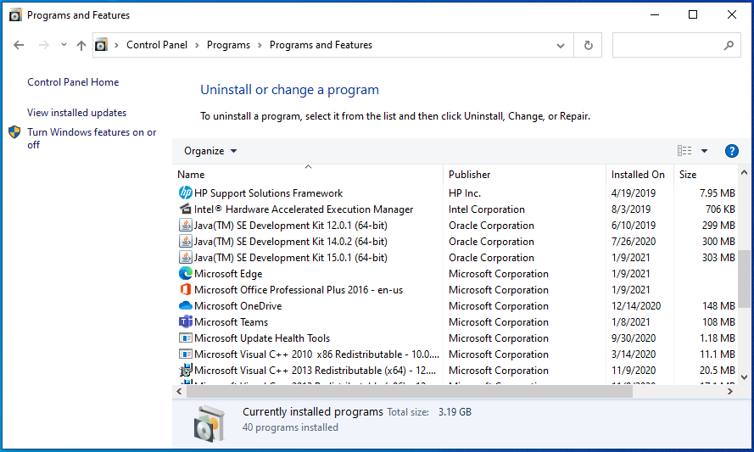
- You should now be able to start Eclipse.

